The solar System

The solar System

Nine major planets are currently known. They are commonly divided into two groups: the inner planets (Mercury, Venus, Earth, and Mars) and the outer planets (Jupiter, Saturn, Uranus, and Neptune). The inner planets are small and are composed primarily of rock and iron. The outer planets are much larger and consist mainly of hydrogen, helium, and ice. Pluto does not belong to either group, and there is an ongoing debate as to whether Pluto should be categorized as a major planet.

The solar system was the only planetary system known to exist around a star similar to the Sun until 1995, when astronomers discovered a planet about 0.6 times the mass of Jupiter orbiting the star 51 Pegasi. Jupiter is the most massive planet in our solar system. Soon after, astronomers found a planet about 8.1 times the mass of Jupiter orbiting the star 70 Virginis, and a planet about 3.5 times the mass of Jupiter orbiting the star 47 Ursa Majoris. Since then, astronomers have found planets and disks of dust in the process of forming planets around many other stars. Most astronomers think it likely that solar systems of some sort are numerous throughout the universe.

Mercury

Mercury orbits closest to the Sun of all the planets, at an average distance of approximately 58 million km (about 36 million mi). The planet’s diameter is 4,879 km (3,032 mi), and its volume and mass are about one-eighteenth that of Earth. Mercury’s mean density is approximately equal to that of Earth and is higher than that of any of the other planets. The force of gravity on the planet's surface is about one-third of that on Earth's surface or about twice the surface gravity on the Moon.

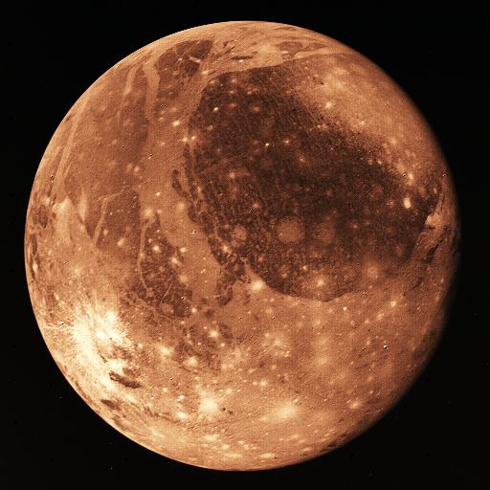

Mercury revolves once about the Sun every 88 days. Radar observations of the planet show that it rotates only once every 58.7 days, two-thirds of its period of revolution. Only three of the planet’s days, therefore, occur during every two of its years. The side facing the Sun gets very hot, while the side facing away quickly cools to frigid temperatures. The point in Mercury's orbit at which the planet is closest to the Sun (called the planet’s perihelion) moves a tiny amount every orbit, too much to be accounted for by the gravitational influence of other planets. The observation of these changes in Mercury's perihelion was one of the first confirmations of Einstein’s theory of relativity, which predicted their existence.

Mercury’s high density indicates that the relatively dense and abundant element iron accounts for a large proportion of the planet’s composition. The surface of Mercury, however, contains little iron, suggesting that most of Mercury’s iron is now concentrated in a large iron core. Collisions with other protoplanets early in the history of the solar system may have stripped away much of Mercury’s low-density crust, leaving behind a dense, iron-rich core.

Venus

Except for the Sun and the Moon, Venus is the brightest object in the sky. The planet is called the morning star when it appears in the east at sunrise and the evening star when it is in the west at sunset. In ancient times the evening star was called Hesperus and the morning star Phosphorus or Lucifer. Because of the distances of the orbits of Venus and Earth from the Sun, Venus is never visible more than three hours before sunrise or three hours after sunset.
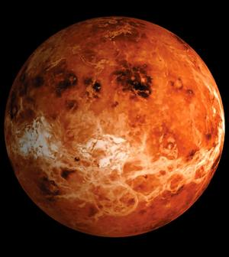

When viewed through a telescope, the planet exhibits phases like the Moon. Maximum brilliance (a stellar magnitude of -4.4, 15 times as bright as the brightest star) is seen in the crescent phase when Venus is closer to Earth. Venus’s full phase appears smaller and dimmer because it occurs when the planet is on the far side of the Sun from Earth. The phases and positions of Venus in the sky repeat every 1.6 years. Transits of Venus (when the planet moves across the face of the Sun as seen from Earth) are rare, occurring in pairs at intervals of a little more than a century.

Earth

Earth is the only planet known to harbor life, and the “home” of human beings. From space Earth resembles a big blue marble with swirling white clouds floating above blue oceans. About 71 percent of Earth’s surface is covered by water, which is essential to life. The rest is land, mostly in the form of continents that rise above the oceans.

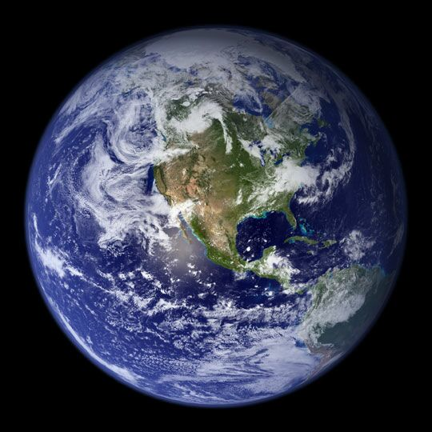

For thousands of years, human beings could only wonder about Earth and the other observable planets in the solar system. Many early ideas—for example, that the Earth was a sphere and that it traveled around the Sun—were based on brilliant reasoning. However, it was only with the development of the scientific method and scientific instruments, especially in the 18th and 19th centuries, that humans began to gather data that could be used to verify theories about Earth and the rest of the solar system. By studying fossils found in rock layers, for example, scientists realized that the Earth was much older than previously believed.

As a result of this recent space exploration, we now know that Earth is one of the most geologically active of all the planets and moons in the solar system. Earth is constantly changing. Over long periods of time land is built up and worn away, oceans are formed and re-formed, and continents move around, break up, and merge.

The Moon

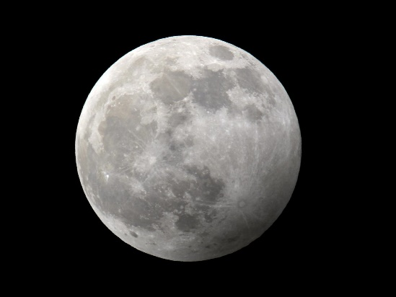

Telescopes have revealed a wealth of lunar detail since their invention in the 17th century, and spacecraft have contributed further knowledge since the 1950s. Earth’s Moon is now known to be a slightly egg-shaped ball composed mostly of rock and metal. It has no liquid water, virtually no atmosphere, and is lifeless. The Moon shines by reflecting the light of the Sun. Although the Moon appears bright to the eye, it reflects on average only 7 percent of the light that falls on it. This reflectivity, called albedo, of 0.07 is similar to that of coal dust.

The diameter of the Moon is about 3,480 km (about 2,160 mi), or about one-fourth that of Earth. The Moon’s mass is only 1.2 percent of Earth’s mass. The average density of the Moon is only three-fifths that of Earth, and gravity at the lunar surface is only one-sixth as strong as gravity at sea level on Earth. The Moon moves in an elliptical (oval-shaped) orbit around Earth at an average distance of 384,403 km (238,857 mi) and at an average speed of 3,700 km/h (2,300 mph). It completes one revolution in 27 days 7 hours 43 minutes. For the Moon to go from one phase to the next similar phase—as seen from Earth—requires 29 days 12 hours 44 minutes. This period is called a lunar month. The Moon rotates once on its axis in the same period of time that it circles Earth, accounting for the fact that virtually the same portion of the Moon (the “near side”) is always turned toward Earth.

Mars

Mars is the fourth planet from the Sun and orbits the Sun at an average distance of about 228 million km (about 141 million mi). Mars is named for the Roman god of war and is sometimes called the red planet because it appears fiery red in Earth’s night sky.
Mars is a relatively small planet, with about half the diameter of Earth and about one-tenth Earth’s mass. The force of gravity on the surface of Mars is about one-third of that on Earth. Mars has twice the diameter and twice the surface gravity of Earth’s Moon. The surface area of Mars is almost exactly the same as the surface area of the dry land on Earth. Mars is believed to be about the same age as Earth, having formed from the same spinning, condensing cloud of gas and dust that formed the Sun and the other planets about 4.6 billion years ago.

Phobos

Phobos orbits Mars at an average distance of only 9,378 km (5,827 mi), closer to its planet than any other moon in the solar system. In fact, the moon is so close to the planet that tidal forces caused by Mars’s gravity are slowly dragging the moon down. Phobos spirals inward about 1.8 m (about 6 ft) per century. Around 50 million years from now Phobos will be so close to Mars that the moon will either break apart, forming a ring around the planet, or crash into the Martian surface. Because it is so near Mars, Phobos completes its nearly circular orbit every 7.65 hours, whizzing around the planet three times each day. As seen from the surface of Mars, Phobos crosses the Sun’s disk about 1,300 times a year. The moon is tidally locked, which means that it keeps the same face toward Mars at all times, just as Earth’s Moon keeps the same face toward Earth. Phobos therefore rotates once per orbit around Mars.

Deimos

Deimos orbits Mars at an average distance of 23,460 km (14,580 mi), completing an orbit once every 1.26 Earth days. The moon’s orbit is almost circular and is only slightly tilted relative to the Martian equator. Deimos rotates once in exactly the same amount of time that it completes one orbit, keeping one face toward Mars at all times, just as Earth’s moon shows only a single face as seen from Earth’s surface.

Jupiter

Jupiter orbits the Sun at an average distance of 780 million km (480 million mi), which is about five times the distance from Earth to the Sun. Jupiter’s year, or the time it takes to complete an orbit about the Sun, is 11.9 Earth years, and its day, or the time it takes to rotate on its axis, is about 9.9 hours, less than half an Earth day.

Io

Io has a large, dense iron core at its center surrounded by a mantle that contains molten compounds of silicon and oxygen. Its crust, the moon’s outer layer, is made up mostly of sulfur and sulfur compounds, which color the moon’s surface with areas of yellow, orange, red, white, blue, brown, and black. Io is the most volcanically active world in the solar system, with hundreds of volcanoes dotting its surface. Some shoot plumes of molten sulfur and sulfur dioxide gas up to 300 km (186 mi) high. These volcanic vents also release lava hotter than any other planetary surface temperature ever recorded in the solar system—as hot as 1727°C (3140°F). Astronomers have identified magnesium-rich silicates, a type of lava that only melts at very high temperatures, around these vents.

Europa

Europa is slightly smaller than Earth’s moon, with a radius of 1,565 km (972 mi). Like Earth’s moon, it ranks among the ten largest moons in the solar system. Europa is made up mostly of silicate rock, rock containing compounds of silicon and oxygen. The surface of Europa is covered by water ice. About 5 km (about 3 mi) beneath this ice, there may be a 50-km-deep (30-mi-deep) ocean of water or a 100-km-deep (60-mi-deep) ocean of slushy ice. Gravitational forces keep Europa’s interior warm. The moon’s orbit is not a completely smooth ellipse because Europa is pulled slightly by the gravity of the nearby moons Ganymede and Io. As a result, Europa rocks as it orbits Jupiter and is squeezed and stretched slightly by the competing pulls of Jupiter, Ganymede, and Io. This flexing causes friction inside the moon, producing heat that keeps the subsurface ice slushy or liquid.

Ganymede

Ganymede’s solid ice crust is thought to be about 75 km (about 45 mi) thick. Some scientists believe that the moon’s mantle, the layer that underlies the crust, may contain liquid water or ice slush. The moon’s surface is a combination of old, heavily cratered dark areas and younger light areas. Unlike craters on rocky worlds, such as Earth’s moon, Ganymede’s craters have flat floors and sagging walls because of slowly flowing ice that is smoothing the moon’s surface. The largest cratered area is Galileo Regio. This young terrain is striped by parallel grooves and ridges called sulci. Scientists theorize that the sulci date from a time when the gravity of the large, neighboring moon Callisto pulled Ganymede into a slightly elliptical (oval-shaped) orbit. The combination of Jupiter’s gravity and Callisto’s gravity squeezed and stretched Ganymede slightly. Rocks inside the moon rubbed together, producing heat and softening the crust. This softening caused large sections of ice to slide and bump into each other, rumpling the crust into sulci. Ganymede’s orbit is now more circular, so its crust is colder and more solid. Ganymede probably has an oxygen atmosphere much too thin to breathe. The oxygen may be produced as sunlight or charged particles trapped in Jupiter’s magnetic field break water into oxygen and hydrogen. In 1995 the Hubble Space Telescope found evidence of ozone, a molecule made up of oxygen, around Ganymede.

Callisto

Callisto is spherical and is the third-largest moon in the solar system. The moon has a radius of 2,403 km (1,493 mi), making it nearly the same size as the planet Mercury. Since Callisto consists mostly of low-density water ice, however, the moon is only one-third as massive as rocky, metallic Mercury. Callisto’s interior is probably not differentiated into a rocky core surrounded by lighter icy material, like that of the other three large moons of Jupiter—Io, Europa, and Ganymede. Instead, scientists believe that the entire moon is a mixture of rock and ice, with the percentage of rock in the mixture increasing toward the moon’s center.

Saturn

Saturn's most distinctive feature is its ring system, which was first seen in 1610 by Italian scientist Galileo, using one of the first telescopes. He did not understand that the rings were separate from the body of the planet, so he described them as handles (ansae). The Dutch astronomer Christiaan Huygens was the first to describe the rings correctly. In 1655, desiring further time to verify his explanation without losing his claim to priority, Huygens wrote a series of letters in code, which when properly arranged formed a Latin sentence that read in translation, “It is girdled by a thin flat ring, nowhere touching, inclined to the ecliptic.” The rings are named in order of their discovery, and from the planet outward they are known as the D, C, B, A, F, G, and E rings. These rings are now known to comprise more than 100,000 individual ringlets, each of which circles the planet.

Mimas

Mimas’s most distinctive feature is the asteroid impact crater, Herschel. The 130-km (78-mi) crater is one-third as wide as Mimas itself. Herschel was first seen in pictures taken by the United States Voyager probes in 1980. Herschel has walls 5 km (3 mi) high, a floor 10 km (6 mi) deep, and a central peak 6 km (3.6 mi) high. Mimas also has many cracks, called chasma. Most occur on the side of Mimas opposite Herschel crater. These were probably generated by stresses caused by the asteroid impact. The largest chasma are called Ossa, Pelion, Qeta, and Pangea. The rest of Mimas’s surface is covered with smaller craters. The largest of these, Arthur crater, is less than half as big as Herschel. There are few signs of geological activity, and Mimas is too small to hold onto an atmosphere.

Titan

Titan’s surface is hidden beneath thick orange clouds. The United States Voyager probes were unable to see surface details on Titan. However, planetary scientists who have studied Titan’s chemistry and temperature believe that there may be lakes or even oceans of the chemical ethane on the moon’s surface. The Hubble Space Telescope looked at heat reflected from Titan and was able to make out some surface features, including an elevated region that is the size of Australia. If Titan has ethane seas, then this region may be like a continent.

The Sun

The Sun is a huge mass of hot, glowing gas. The strong gravitational pull of the Sun holds Earth and the other planets in the solar system in orbit. The Sun’s light and heat influence all of the objects in the solar system and allow life to exist on Earth.

Microsoft ® Encarta ® Reference Library 2005. © 1993-2004 Microsoft Corporation. All rights reserved.

